Little SPARK: Simple Play Adaptations to Reference for Kids

Feelings Chart and Cards
Description: | Image:
Each Feelings Chart comes equipped with 1 felt background board/ folder, 1 "I Feel" card, 19 feelings felt-backed cards, 1 "I Need" card, 19 activities felt-backed cards. Emotion cards can help children identify their own feelings and emotions. | 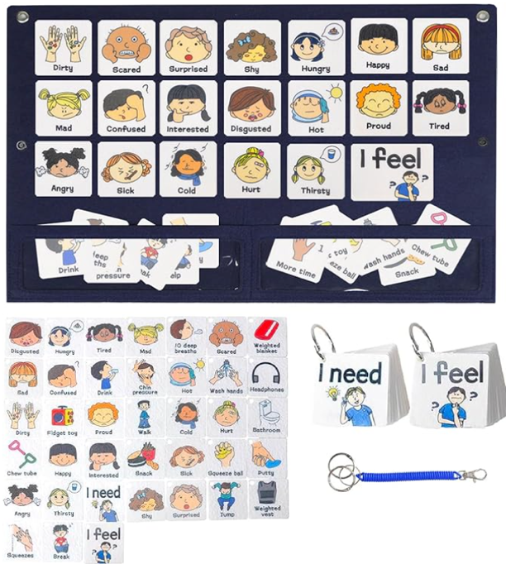

Who Might Benefit?
Those who have difficulty identifying feelings, need support determining what to do when they have certain feelings, or have motor challenges and are unable to draw picture to depict feelings.
Why Use?
Provides an opportunity to talk about feelings, show how they are feeling without talking, and recognize the choices they have to change how they feel.
Instructions for Use: | Adaptation Ideas:
Environmental Considerations  - Quiet, private area for discussion of feelings.  Positioning & Alternate Positioning  - Use in any position; chart could be displayed in the classroom.  Basic Play/Use Extended Play/Use  - Use in a one-on-one setting, or during whole group activities.  - Point out opportunities/area in the classroom where some the “needs” identified on the cards can be met (e.g. earphones, break, fidget, bathroom).  Play/Use with Others  - During group time, have children share their feelings and why they feel that way.  - When reading stories or singing songs, refer to the chart.  - Draw cards and mimic the facial expression/action depicted. | Build It Up  - Consider mounting pictures on foam board and add Velcro to the backs.  Stabilize It  - Smaller number of cards could be arranged on a trifold display board made from foam core board.  Simplify It  - Reduce the number of emotions.  Add Sensory Cues  - Add puff paint or Wikki Stix to trace outlines of pictures.  Communication Support  - Record feelings on a voice output device with added visual support representing the recorded feeling.  DIY Alternatives  - Use chart paper and drawings of stamps to illustrate feelings and needs.

Words to Encourage Play/Use
I feel  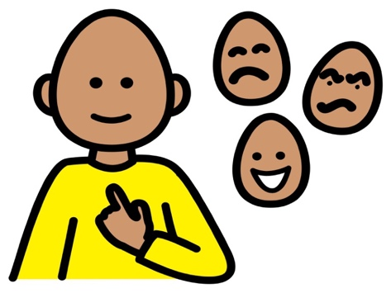 | Happy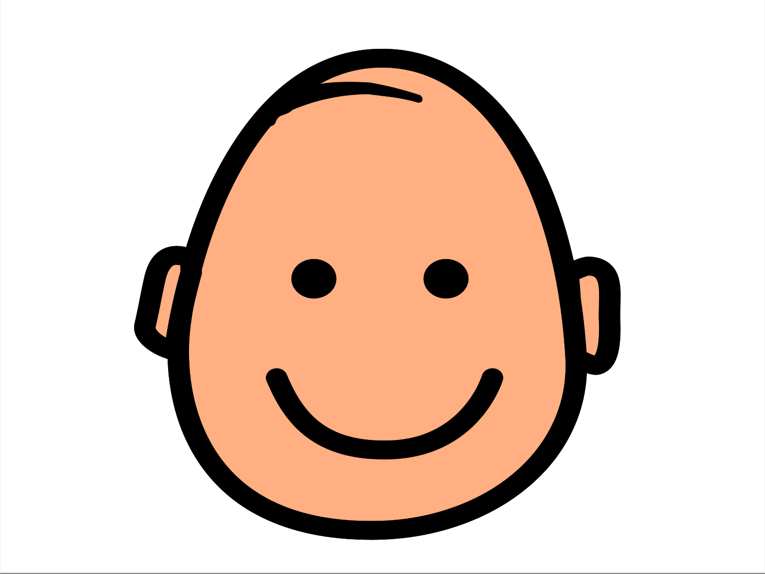 | Sad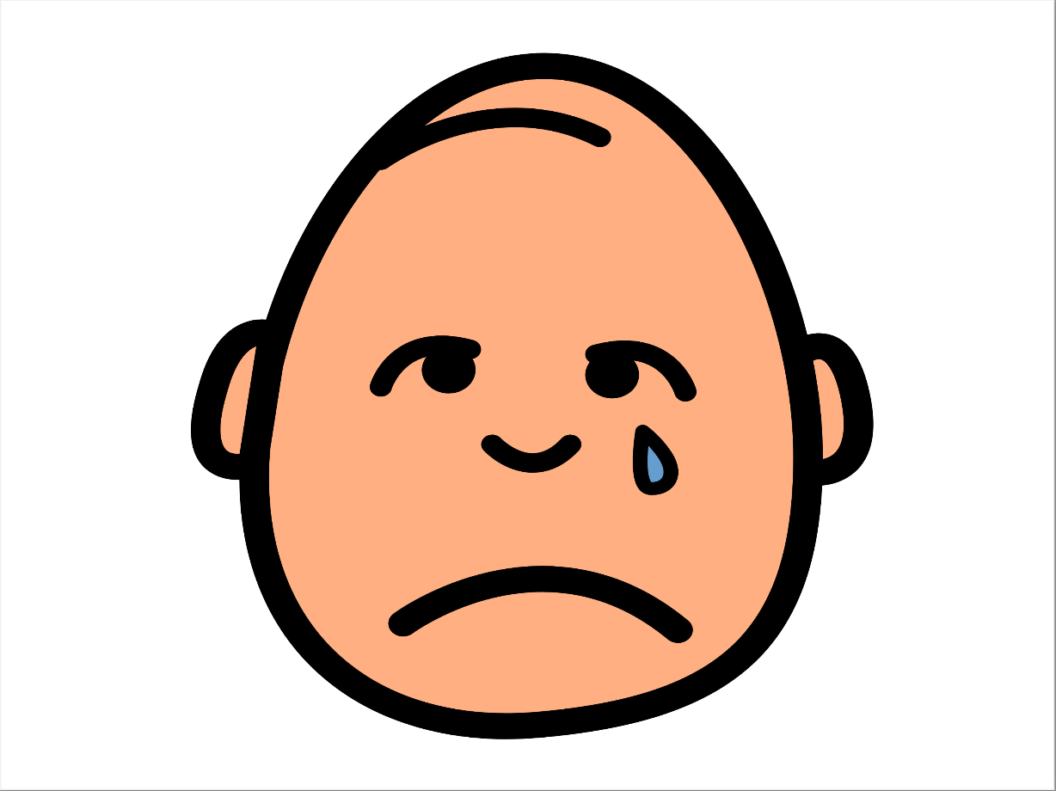
Sick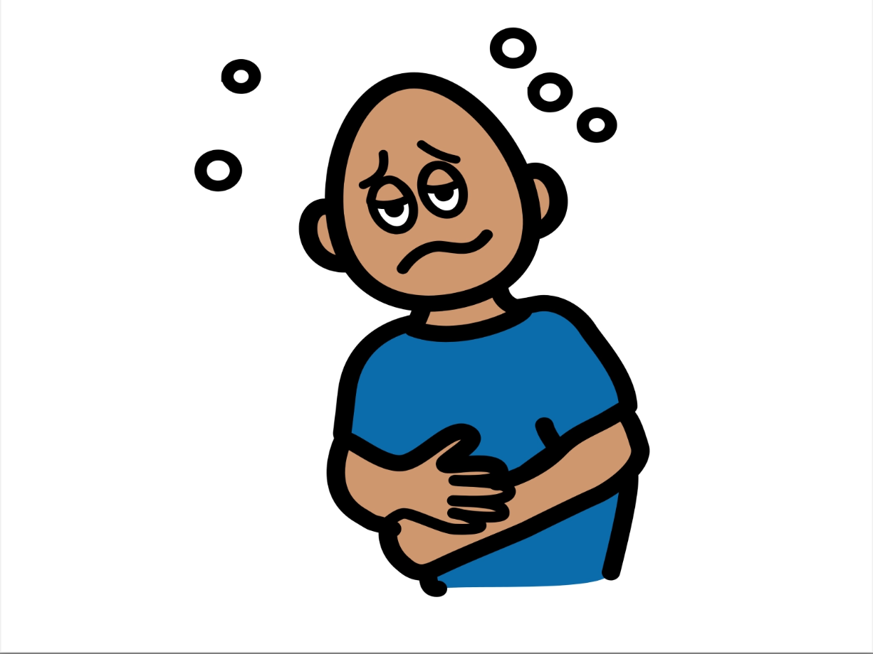 | Surprised | Tired 
Confused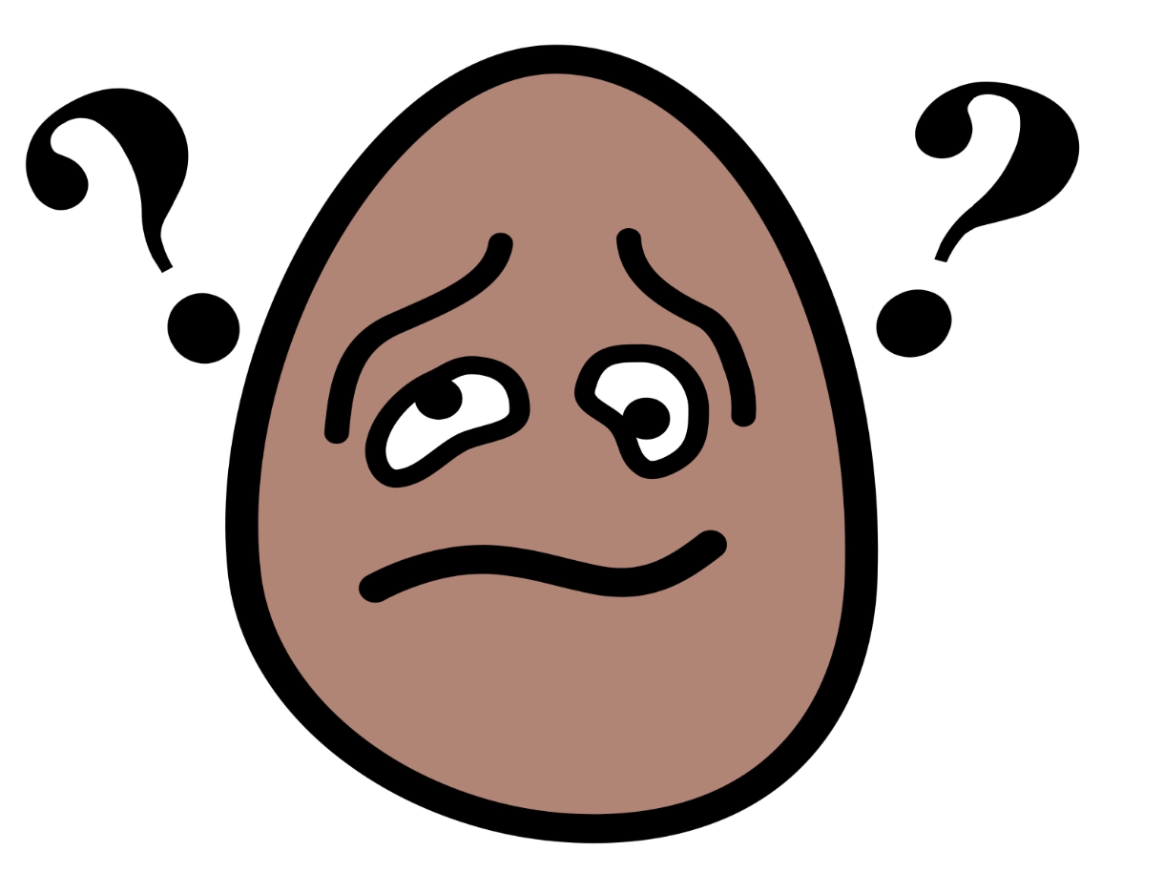 | Mad | Scared  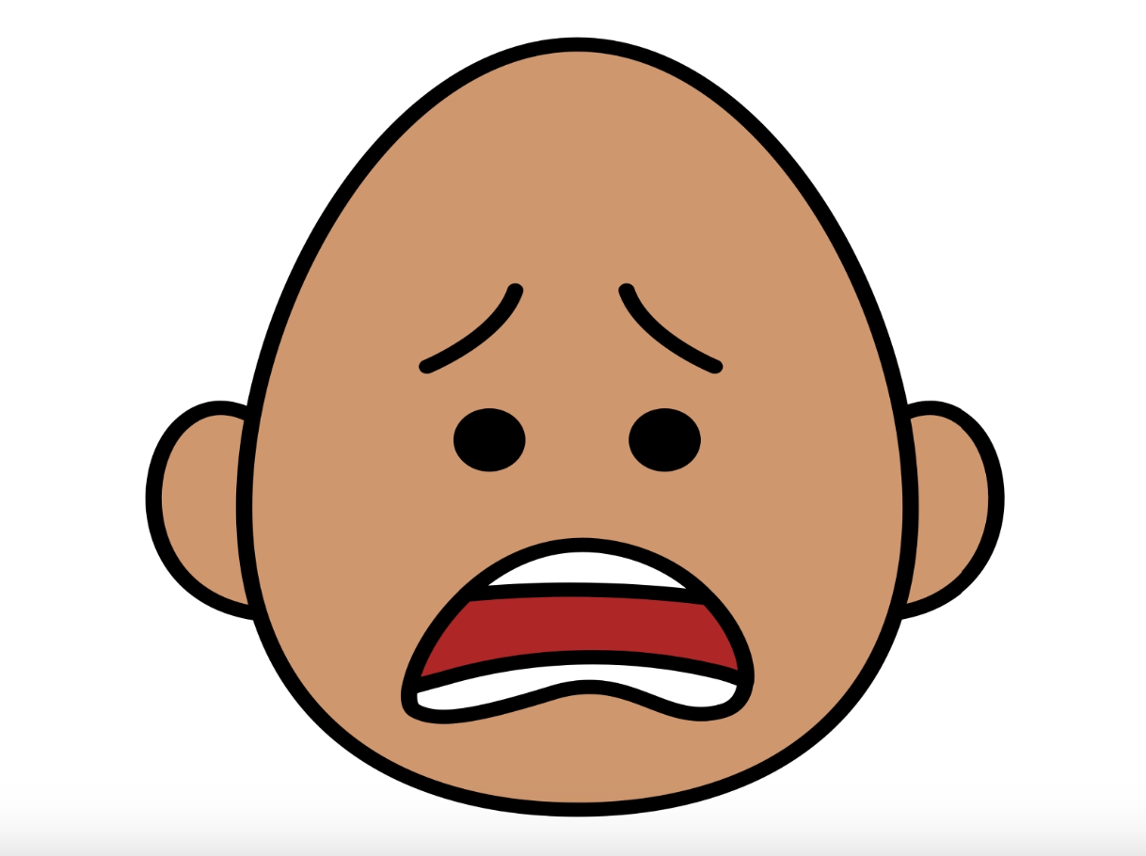
*”Adaptations” adapted from: Haugen’s Modes for Adapting Toys based on materials from the "Let's Play" Project at the University of Buffalo.
PCS is a trademark of Tobii Dynavox, LLC. All rights reserved. Used with permission.

